MONDAY | TUESDAY |  | WEDNESDAY | THURSDAY | FRIDAY
03  Manager’s Choice |  | 04  Manager’s Choice | 05  Manager’s Choice | 06  Manager’s Choice | 07  Manager’s Choice
10  Manager’s Choice | 11  Manager’s Choice |  | 12  Breakfast  Breakfast Pizza Bagel  PB&J Breakfast Sandwich  Fruit Cup  Lunch  Three Cheese Calzone V  Baked Chicken Tenders  PB&J Sandwich  WG Dinner Roll  Steamed Carrots V  Steamed Broccoli V  Fresh Fruit | 13  Breakfast  Cheese Omelet Sandwich  PB&J Breakfast Sandwich  Fresh Fruit  Lunch  Chicken Quesadilla  Beef Nachos w/ Salsa V option available  PB&J Sandwich V  Spicy Pinto Beans  Fresh Tossed Salad  Fruit Cup | 14  Breakfast  Southern Chicken Filet Biscuit  PB&J Breakfast Sandwich  Fruit Cup  Lunch  Chicken Filet Sandwich  Juicy Stuffed Burger  PB&J Sandwich V  Crinkle Cut Sweet Potato Fries V  Bush’s Baked Beans V  Fresh Fruit
17  Breakfast  Protein Packed Breakfast Boat  PB&J Breakfast Sandwich  Fruit Cup  Lunch  Fish Sandwich  Pizza Crunchers V  PB&J Sandwich V  Steamed Broccoli V  Savory Green Beans V  Fresh Fruit | 18  Breakfast  Turkey Sausage, Cheese Omelet & Toast  PB&J Breakfast Sandwich  Fresh Fruit  Lunch  Roasted Chicken  Hamburger/Cheeseburger  PB&J Sandwich V  Southern Biscuit  Glazed Sweet Potatoes V  Mixed Veggies V  Fruit Cup |  | 19  Breakfast  Southern Chicken Filet Biscuit  PB&J Breakfast Sandwich  Fruit Cup  Lunch  Chicken Quesadilla  Baked Chicken Tenders  PB&J Sandwich V  Texas Toast  Fresh Tossed Salad V  Steamed Carrots V  Fresh Fruit | 20  Breakfast  Breakfast Pizza Bagel  PB&J Breakfast Sandwich  Fresh Fruit  Lunch  Turkey Pot Pie w/ Biscuit  Beef Nachos w/ Salsa V option available  PB&J Sandwich V  Black Beans V  Mixed Veggies V  Fruit Cup | 21  Breakfast  Cheese Omelet Sandwich  PB&J Breakfast Sandwich  Fruit Cup  Lunch  Chicken Filet Sandwich  Juicy Stuffed Burger  PB&J Sandwich V  Savory Green Beans V  Seasoned Fries V  Fresh Fruit
24  Breakfast  Turkey Sausage Biscuit  PB&J Breakfast Sandwich  Fruit Cup  Lunch  Fish Nugget w/ Hushpuppies  Pizza Crunchers  PB&J Sandwich  Vegetable Soup  Fresh Tossed Salad  Fresh Fruit | 25  Breakfast  Turkey Bacon, Egg, & Cheese on Ciabatta  PB&J Breakfast Sandwich  Fresh Fruit  Lunch  Chicken (tenders) & Waffles  Hamburger / Cheeseburger  PB&J Sandwich  Wake Rounds  Mixed Veggies  Fruit Cup |  | 26  Breakfast  Southern Cheese Omelet Biscuit  PB&J Breakfast Sandwich  Fruit Cup  Lunch  Baked Lasagna V option available  Baked Chicken Tenders  PB&J Sandwich  Texas Toast  Garlic Sautéed Spinach  Straight Cut Fries  Fresh Fruit | 27  Breakfast  Protein Packed Breakfast Boat  PB&J Breakfast Sandwich  Fresh Fruit  Lunch  Grilled Honey BBQ Rib Sandwich  Beef Nachos w/ Salsa V option available  PB&J Sandwich  Spicy Pinto Beans  Steamed Broccoli  Fruit Cup | 28  Breakfast  Southern Chicken Filet Biscuit  PB&J Breakfast Sandwich  Fruit Cup  Lunch  Chicken Filet Sandwich  Juicy Stuffed Burger  PB&J Sandwich  Southern Green Beans  Savory Sweet Potato Wedges  Fresh Fruit
USDA Non-discrimination statement: http://childnutrition.ncpublicschools.gov/information-resources/civil-rights/usda-non-discrimination-statement

June 2019 | MENU
Wake County Public School System
K-5 Breakfast & Lunch Menu

K-5 Paid Meal Prices:
Breakfast: $1.25
Lunch: $2.55
Adults: A la Carte Pricing

K-5 Reduced Meal Prices:
*Breakfast: $0.30
Lunch: $0.40

* The actual charge may be less, depending on funding

Breakfast includes choice of: Entrée, fruit & milk. Students must select a fruit/juice.

Daily Breakfast Items: • Assorted Milk • 100% Fruit Juice

Additional Breakfast Options • Variety of Cereals w/ Mozzarella Stick V • Breakfast Box V • Pop-tart V

Lunch includes a choice of: Entrée with grain/bread, 1-2 vegetables, 1-2 fruits & milk. Students must select a fruit and/or vegetable.

V Symbolizes the daily vegetarian entree option

Daily Lunch Items: • Assorted Milk • Entree Salad V
• Smucker’s PB&J Sandwich

Additional Lunch Options:
• Yogurt Box V • Mozzarella String Cheese Box V • Fruit Parfait V • Hummus Box V • Peanut Butter Box V • Ants on a Log Box V

Milk Choices: • Fat Free Unflavored, Strawberry, Chocolate, and Vanilla

All “Additional” options are not available in all schools. Please contact your schools Dining Room Manager for additional menu information. Menu selection is subject to change at any time.

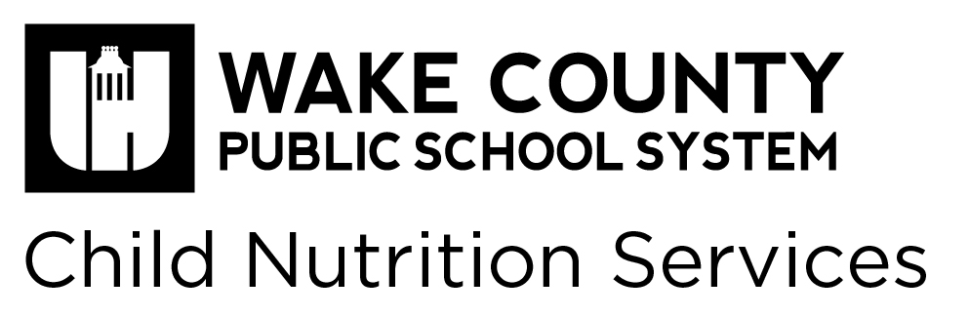

Manager’s Choice Days:
Please contact the Dining Room Manager of your site for menu information.

